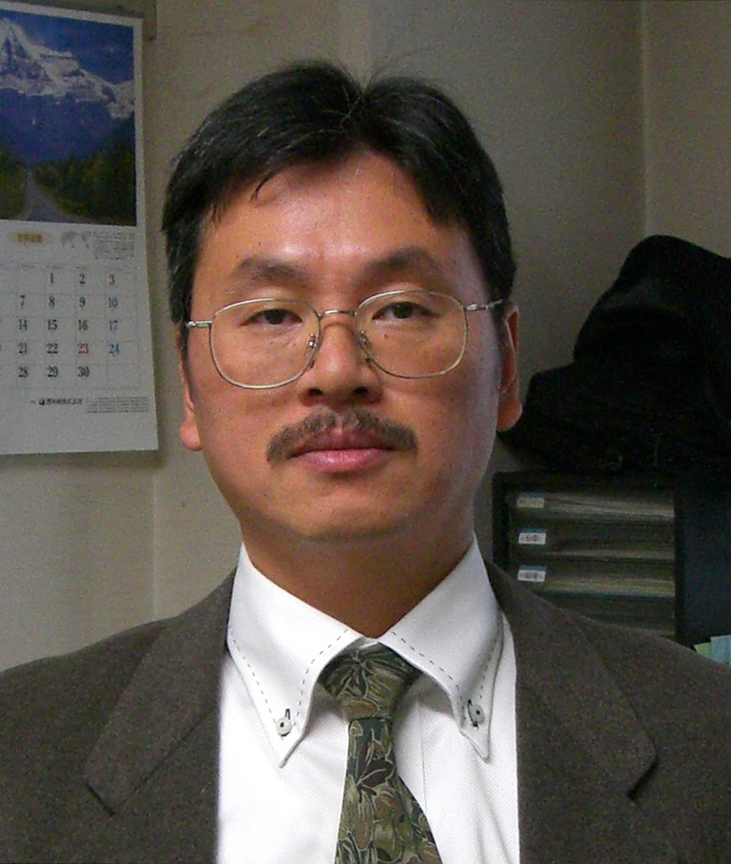
Katsutoshi Hori

Professor, Department of Biotechnology, Nagoya University
Fro-cho, Chikusa-ku, Nagoya, 464-8603, Japan

E-mail: khori@nubio.nagoya-u.ac.jp

Education:
B.S. Applied Biological Science, Tokyo University of Science, Chiba, Japan, 1988
M.S. Biochemical Science, Tokyo Institute of Technology, Yokohama, Japan, 1991
Ph.D. Environmental Engineering Tokyo Institute of Technology, Yokohama, Japan, 1995

Professional Career:
1994-1995: Researcher, Petrochemical Research Center, Sumitomo Chemical Corporation, Chiba, Japan
1995-1998: Manager and Chief Engineer, Environmental assessment section, Green Blue Corporation, Tokyo, Japan
1998-2004: Assistant Professor, Department of Bioengineering, Graduate School of Bioscience and Biotechnology, Tokyo Institute of Technology, Yokohama, Japan
2004-2011: Associate Professor, Department of Materials Science and Engineering, Nagoya Institute of Technology, Nagoya, Japan
2006-2010: Research Fellow, PRESTO (Precursory Research for Embryonic Science and Technology), JST (Japan Science and Technology Agency)
2008-2011: Director, Project Research Center for Interfacial Microbiology, Nagoya Institute of Technology
2010: Invited Professor, Chemical Engineering, Tsinghua University, Beijing, China
2010: Invited Associate Professor, EcoTopia Science Institute, Nagoya University
2011-present: Professor, Department of Biotechnology, Nagoya University, Nagoya, Japan

Research Interests:
- Development of interfacial microbiological process for white biotechnology
- Elucidation of the mechanism microbial adhesion and biofilm formation and their application
- Biological wastewater treatment and water purification
- Design of functional proteins as new nanomaterials

